Visitor Policy

Policy:
Ehatare Retirement & Nursing Home has a responsibility to ensure residents receive visitors safely to help maintain a safe Home and to protect against the risk of respiratory infections. This policy balances mitigating measures to protect the health and safety of residents, staff and visitors, with the physical, mental, emotional, and spiritual needs of residents for their quality of life and in consideration of the mental health and emotional well-being of residents and their loved ones. All visitors must comply with the requirements set out in this policy.

This policy complies with all applicable laws, including the Act and O. Reg. 246/22 made under the Fixing Long-Term Care Act, 2021(s267), current ministry requirements, applicable legislation, and regulations, and is guided by the policies of the Ministry for Seniors and Accessibility (MSAA) and the Retirement Homes Regulatory Authority (RHRA).

If anything in this policy conflicts with requirements in applicable legislation or regulations or any other provincial requirements, including any applicable emergency orders, directives, directions, guidance, recommendations or advice issued by the CMOH and applicable to retirement and nursing homes, those requirements prevail, and the residence will follow them.

Guiding Principles
In addition to the requirements established in the Fixing Long-Term Care Homes Act, the Retirement Homes Act, 2010 this policy is guided by the following principles:
- Safety: Any approach to visiting, absences, and activities must balance the health and safety needs of residents, staff, and visitors, and ensure risks of infection are mitigated.
- Mental Health and Emotional Well-being: Allowing visitors, absences, and activities is intended to support the overall physical, mental, and emotional wellbeing of residents by reducing any potential negative impacts related to social isolation.
- Equitable Access: All residents must be given equitable access to receive visitors and participate in activities consistent with their preferences and within restrictions that safeguard residents, staff, and visitors.
- Flexibility: The physical characteristics /infrastructure of the home, its staffing availability, whether the home is in outbreak or in an area of widespread community transmission, and the status of the home with respect to infection prevention and control (IPAC) including personal protective equipment (PPE) are all variables to consider when administering home-specific policies for visiting, absences, and activities.
- Autonomy: Residents have the right to choose their visitors. Residents also have the right to designate their caregivers. If a resident is unable do so, substitute decision-maker(s) may designate caregivers.
- Visitor Responsibility: Visitors have a crucial role to play in reducing the risk of infection for the safety of residents and staff by adhering to visitor policy requirements related to screening, IPAC and PPE and any precautions described in this policy.
- COVID-19 Vaccination: The goal of the provincial COVID-19 vaccination program is to protect Ontarians from COVID-19. Vaccines help reduce the number of new cases and, most importantly, severe outcomes including hospitalizations and death due to COVID-19. All individuals, whether or not they have received a COVID-19 vaccine, must continue to practice the recommended public health measures and comply with all applicable laws for the ongoing prevention and control of COVID-19 infection and transmission.

Co-Located Home
In a co-located long-term care and retirement home that is not physically and operationally independent (i.e. there are separate entrances and no mixing of residents or staff between the retirement home and the LTC home), the policies for the LTC home and the retirement home should align as possible.

Visitors Log
In accordance with section 267(2) of O. Reg. 246/22, homes must maintain visitor logs of all visits to the home. The visitor’s log includes, at minimum:
- The name and contact information of the visitor
- Time and date of the visit
- The purpose of the visit (for example, the name of resident visited)
These logs are kept for at least 30 days and can be readily available to the local public health unit for contact tracing purposes upon request.

General Visits and Essential Caregivers
Ontario has eased public health and workplace safety measures including removing the mask mandate for public areas and transit systems. Ensuring the health and safety of our seniors, families, and staff remains Ehatare foremost priority. In light of the current trends in respiratory illnesses across Ontario, Ehatare has reinstated the mandatory masking policy. This measure is crucial in mitigating the risk of infection and safeguarding our community during the upcoming respiratory and flu season.

Although Ehatare is not imposing mandatory vaccination for staff, students, volunteers, support workers, caregivers, and general visitors, we highly encourage everyone to stay up to date with all their vaccinations to protect themselves and those around them.

Types of Visitors
There are two categories of visitors: Essential Visitors and General Visitors.

Not Considered Visitors
Long-Term Care and Retirement Home staff (as defined under the Acts), volunteers, and student placements are not considered visitors as their access to the home is determined by the licensee.

Essential Visitors/Support Workers -
There are no limits on the total number of essential visitors allowed to come into a home at any given time. Essential visitors are the only visitors who are allowed during an outbreak in a home or area of a home or when a resident has failed screening, is symptomatic or in isolation.

As per O. Reg. 246/22 under the Fixing Long-Term Care Act, 2021, there are four types of essential visitors:
(a) a caregiver, as defined under section 4 of O. Reg. 246/22
(b) a support worker who visits a home to provide support to the critical operations of the home or to provide essential services to residents
(c) a person visiting a very ill resident for compassionate reasons including, but not limited to, hospice services or end-of-life care
(d) a government inspector with a statutory right to enter a long-term care home to carry out their duties

Essential Caregivers – scheduling and length and frequency of visits
An Essential Caregiver provides care to a resident including supporting feeding, mobility, personal hygiene, cognitive stimulation, communication, meaningful connection, and assistance in decision-making. They do not have to be family.

Essential Caregivers must be designated by the resident, or if the resident if unable to do so, their substitute decision-maker. The designation should be made in writing to the home so the Home can document it.

There is no limit to the length or frequency of visits by caregivers. However, in the case where a resident resides in an area of the home in outbreak, is symptomatic or isolating under additional precautions, caregiver must follow IPAC measures.

Recognizing there are caregivers who want to volunteer to support more than one resident, in the event of an outbreak, caregivers may support up to two residents who are COVID-19 positive, provided the home obtains consent from all involved residents (or their substitute decision makers). Caregivers may also support more than one resident in non-outbreak situations, with the same expectation regarding resident consent.

General visitors
A general visitor is a person who is not an essential visitor and is visiting to provide nonessential services related to either the operations of the home or a particular resident or group of residents.
General visitors include those persons visiting for social reasons as well as visitors providing non-essential services such as personal care services, entertainment, or individuals touring the home.
Our Homes prioritize the mental and emotional well-being of residents and strive to be as accommodating as possible when scheduling visits with general visitors.

General Visitors should avoid entering the home for 10 days after COVID-19 symptom onset, if possible. If the visit is essential to the resident’s mental/physical well-being, the visitors should consider reducing the risk of infection to residents by masking and limiting direct contact. For further information, retirement homes may reference the MOH’s Outbreak Prevention and Control Guidance

Restrictions during outbreaks or when a resident is isolating

Essential visitors
Essential visitors are the only type of visitors allowed when a resident is isolating or resides in a home or area of the home in an outbreak.

General visitors
General visitors are not permitted:
• when a home or area of a home is in outbreak
• to visit an isolating resident
• when the local public health unit so directs

The number of visitors attending to a palliative resident should be decided on a case-by-case basis; homes should be communicating with families to come to a safe and supportive decision together. Vaccination status

Direction from the local public health unit
In the case where a local public health unit directs a home in respect of the number of visitors allowed, the home must follow the direction of the local public health unit.

Screening
Passive screening is required for any individual entering the long-term care and retirement home.
All visitors should self-screen for any signs and symptoms of respiratory and enteric illness before and during their visits. Visitors are NOT to come into the home if they are not feeling well or exhibit infectious symptoms even if they have tested negative for COVID-19 although exceptions may apply to residents at end-of-life care.
Active screening is not required by the long-term care and retirement home. During suspect/ confirmed outbreaks, the staff and visitors working/ visiting on the affected unit(s) may be required to conduct active screening as per the local Public Health’s direction.
Personal Protective Equipment Use
For IPAC and PPE best practices prior to and during an outbreak, long-term care and retirement home may reference the MOH’s Outbreak Prevention and Control Guidance. For specific requirements for masking, all visitors must adhere to the direction below.

Indoor and Outdoor Masking
• Masks are required for staff, students, volunteers and Essential Visitors who are health care workers, including HCCSS workers based on a point-of-care risk assessment.
• Masks are recommended but not required for staff and Essential Visitors who are not health care workers (e.g., families, friends, and Essential Caregivers who are not health care workers), as well as General Visitors.
Staff, students, volunteers, and Essential Visitors who are health care workers should consider masking during direct resident care to protect high-risk vulnerable residents, particularly during prolonged direct close care (within 2m for over 15 minutes).

Masking Exemptions
• Ehatare has mask friendly policy
• Exceptions to the masking requirements include any individual (staff, student, volunteer, visitor, or resident) who is being accommodated in accordance with the Accessibility for Ontarians with Disabilities Act, 2005 or the Ontario Human Rights Code.

Training & Education
The Home provides education or training to all visitors about physical distancing, respiratory etiquette, hand hygiene, IPAC practices, and proper use of PPE when joining the Home, quarterly and as needed.
This is done by sharing videos and information by form of email blasts, posting signs and having tabletop meetings.

Prior to visiting, please review the home’s infection prevention and control measures including proper use of personal protective equipment (PPE), masking and hand hygiene.

Here are the links:
- Public Health Ontario’s document entitled Recommended Steps: Putting on Personal Protective Equipment (PPE).
- Watched/Re-watched the following Public Health Ontario videos:
- Putting on Full Personal Protective Equipment;
- Taking off Full Personal Protective Equipment; and
- How to Hand Wash
- How to Hand Rub | Public Health Ontario
- IPAC Basics - What is a Point of Care Risk Assessment?

Infection Prevention and Control (IPAC) Practices
Infection Prevention and Control (IPAC) refers to evidence-based practices and procedures that, when applied consistently in health care settings, can prevent or reduce the risk of transmission of microorganisms to residents, staff and visitors.

All visitors must follow the residence’s infection and prevention control protocols (IPAC), including proper use of masks.

IPAC practices include:
- Hand hygiene program
- Screening and surveillance of infections
- Environmental cleaning procedures that reflect best infection control practices
- Use of personal protective equipment
- Outbreak detection and management
- Additional precautions specified to prevent the spread of infection
- Ongoing education on infection control

Respiratory Etiquette
It is important to help reduce the spread of illnesses by using proper respiratory etiquette. This means that instead of covering your mouth with your hands when coughing or sneezing, use your sleeve or a tissue. This reduces the number of germs on your hands, though it is still important to wash your hands after coughing or sneezing.

Respiratory etiquette must be practiced by all visitors during all visits on the residence property to reduce the risk of respiratory transmission.

Following these steps is important:
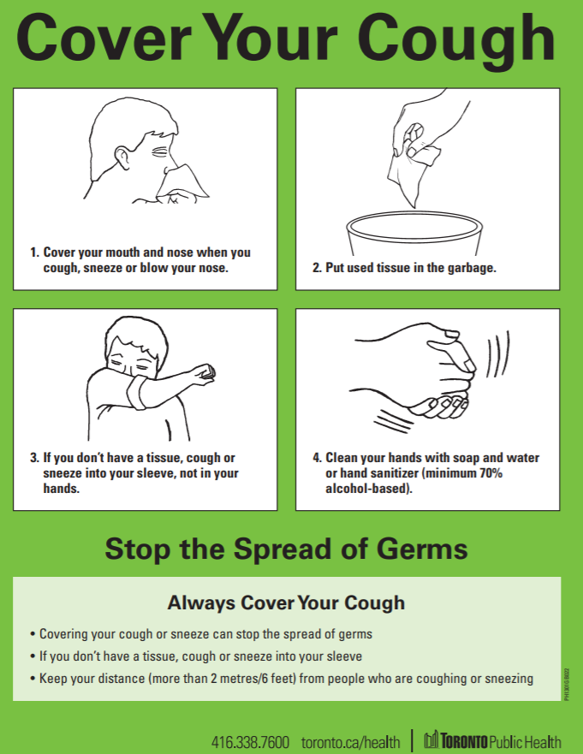

Read more about respiratory etiquette here (Source: Public Health Ontario)

Hand Hygiene
Hand hygiene is a general term referring to any action of hand cleaning and is a fundamental component of infection prevention and control. Touching your eyes, nose or mouth without cleaning your hands or sneezing or coughing into your hands may provide an opportunity for germs to get into your body. Keeping your hands clean through good hygiene practice is one of the most important steps to avoid getting sick and spreading germs to others.

- Handwashing with soap and running water, as opposed to using hand sanitizer, must be done when hands are visibly soiled. Hand hygiene with soap and water – done correctly – removes organisms.
- Hand sanitizers with 70-90% alcohol may be used when your hands are not visibly dirty. Hand hygiene with alcohol-based hand sanitizer – correctly applied – kills organisms in seconds.

All visitors must perform hand hygiene prior to beginning each visit with a resident and if at any time their hands become soiled during the visit. Wash or sanitize your hands at the end of the visit as well.
Follow these steps:
Video: How to Hand Wash

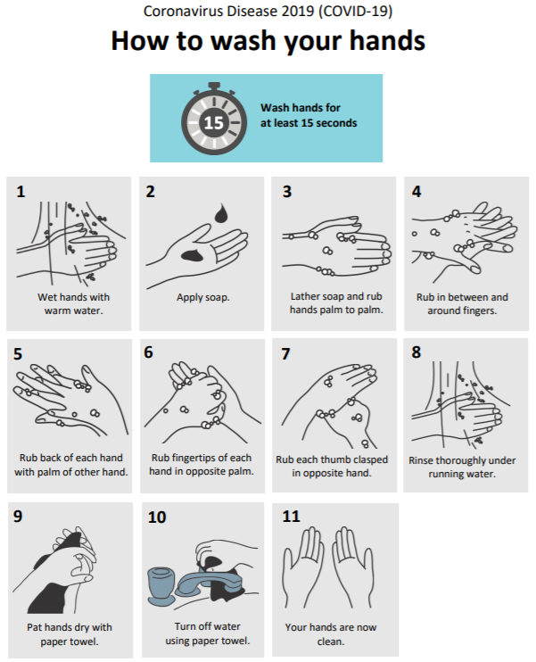
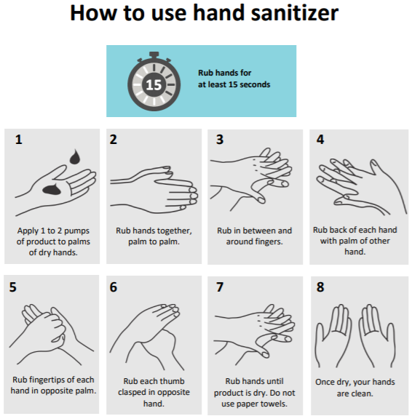
Read more about hand hygiene here (Source: Public Health Ontario)

Proper PPE Etiquette
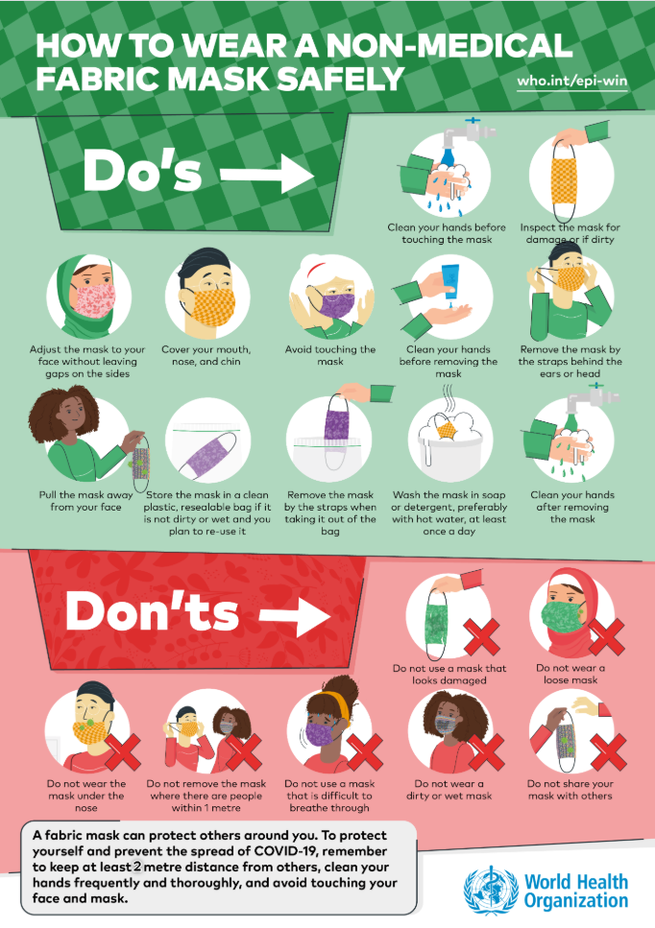

Source: World Health Organization (Non-Medical Fabric Mask)
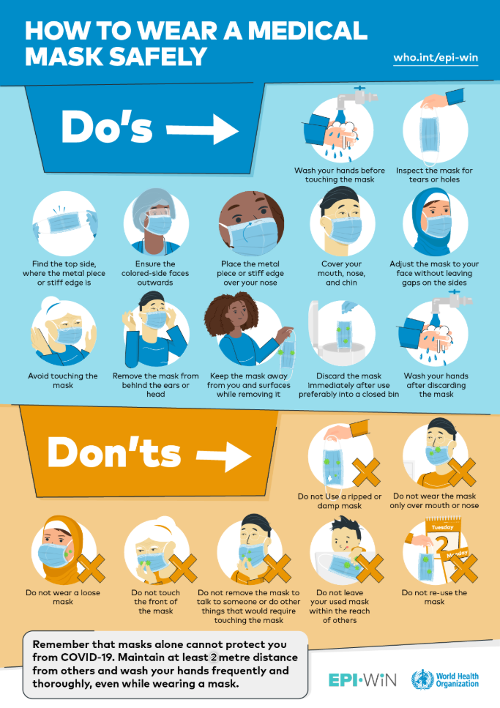

Source: World Health Organization (Medical Mask)

Discontinuation of Visits/Refusal of Entry
All visitors to the residence are expected to comply with the visiting policy. Failure to comply with the residence’s visiting policy may result in the discontinuation of visit(s) when risk of harm from continual non-compliance is considered too high. Refusal of entry will be assessed on a case-by-case basis by management/Designate.

Complaints Process
Should a visitor have a complaint about the administration of the residence’s visiting policy, they may contact Executive Director by phone at 416-284-0828 and the complaint will be responded to in a timely manner. If your concern is not resolved to your satisfaction with the residence’s management, visitors may contact the Ministry of Health and Long-Term Care (MOHLTC) by phone (1-866-434-0144); or the Retirement Homes Regulatory Authority (RHRA) by email (info@rhra.ca) and/or phone (1-855-275-7472).

Accessibility Considerations
The residence is required to meet all applicable laws such as the Accessibility for Ontarians with Disabilities Act, 2005.

